VISVESVARAYA TECHNOLOGICAL UNIVERSITY
JnanaSangama, Belagavi – 590014.

MINI PROJECT REPORT

ON

“Swift and Sweet Food Management System”

Submitted in partial fulfillment for the requirement of 5th semester for the
Degree of Bachelor of Engineering in
INFORMATION SCIENCE & ENGINEERING
For the academic year 2019-20
SUBMITTED BY:
ANOOPKUMAR KULKARNI
[1DB17IS008]
Under the guidance of:
Mrs. Manjula K
Assistant Professor,
Dept. of ISE

DON BOSCO INSTITUTE OF TECHNOLOGY, BENGALURU-560074
DON BOSCO INSTITUTE OF TECHNOLOGY
Kumbalagodu, Bengaluru-560074

DEPARTMENT OF INFORMATION SCIENCE AND ENGINEERING
CERTIFICATE

This is to certify that the Project Report entitled “SWIFT AND SWEET FOOD MANAGEMENT SYSTEM”is a bonafide Mini Project work carried out by ANOOPKUMAR KULKARNI(1DB17IS008), in partial fulfillment of ‘5th’ semester for the Degree of Bachelor of Engineering in Information Science and Engineering of Visvesvaraya Technological University, Belagavi, during the academic year 2019-20. It is certified that all corrections/suggestions indicated for Internal Assessments have been incorporated with the degree mentioned.

Mini Project Guide Head of Department
Mrs. Manjula K Prof. Gowramma G S

Asst. Prof. Head of Department
Dept. of ISE, Dept. of ISE,
DBIT,Bangalore. DBIT,Bangalore.

External Viva

Name of the Examiners Signature with Date
1._________________ _________________
2._________________ _________________

DON BOSCO INSTITUTE OF TECHNOLOGY
Kumbalagodu, Bengaluru -560074
DECLARATION

I, ANOOPKUMAR KULKARNI, student of fifth semester B.E, Department of Information Science and Engineering, Don Bosco Institute of Technology, Kumbalagodu, Bengaluru, declare, that the Mini Project Work entitled “SWIFT AND SWEET FOOD MANAGEMENT SYSTEM” has been carried out by and submitted in partial fulfillment of the requirement of V semester Aug 2019-Jan 2020. The matter embodied in this report has been submitted to any university or institute for the award of any other degree or diploma.

Place: Bengaluru ANOOPKUMAR KULKARNI
Date: (1DB17IS008)

ACKNOWLEDGEMENT

At the various stages in making the mini project, a number of people have given me invaluable comment on the manuscript. I take this opportunity to express my deepest gratitude and appreciation to all those who helped me directly or indirectly towards the successful completion of this project.
I would like to thank Principal Dr. HEMADRI NAIDU T, Don Bosco Institute of Technology for his support though out this project.
I express my whole hearted gratitude to Prof. GOWRAMMA G S, who is our respectable Head of Dept. of Information Science. I wish to acknowledge for his valuable help and encouragement.
In this regard I owe a heartfelt gratitude to my guide Mrs. MANJULA K Asst.Professor of Department of Information Science and Engineering, for her timely advice on the project and regular assistance throughout the project work. I would also like to thank the staff members of Department of Information Science and Engineering for their corporation.

ABSTRACT
Provides a unique platform and a portal through which people can order their favourite food. This portal also provide the complete customer details who has ordered the food through this portal.
It will provide the complete information regarding payments food ordered date and time.
In this portal a customer can add or delete the items from their cart and can order it.
They have different modes of payment also as well. Even this project will keep the complete record of the customer details like the payments details and also provides the variety of food for their customers.
This platform is going to provide a organized platform,where on providing a good quality of the food where we can order the food according to the requirement of the Customer.
CONTENTS
CHAPTERS PAGE NO
1. INTRODUCTION. 1-3
1.1 Aim.
1.2 Objective
1.3 Scope
1.4 Advantages/Disadvantages.
1.5 Technology Used
1.6 System Requirements

2. OBJECTIVES. 4

3. ER DIAGRAM. 5

4. SCHEMA DIAGRAM. 6

5. DATA TABLES. 7-8

6. SOURCE CODES. 8-13

7. SNAPSHOTS.
7.1 Admin login page 14
7.2 Register page 15
7.3 Foodmenu page 15
7.4 Order Details page 16
7.5 Food_details page 17
7.6 Food_details1 page 18
7.7 Receipt page 19

8. CONCLUSION. 22

9. REFERENCES. 23

Chapter-1
INTRODUCTION
I have developed Swift and sweet Food Management System to get rid from manual entry and record system and try to give easy and simple database management system to maintain the record of food details.This is generally used by Admin. This system is useful in keeping the record of the Customer, Food details and registration details and many more things. Since the information is maintained by a single person (Admin), hence the data is safe .By using this System, we can make the system better and quick way.

1.1 Aim
The main aim of designing this project is to get rid from manual entry and record system and try to give easy and simple database management system for swift and sweet food management system.

1.2 Objective
The main objective is to keep the record of the food details, registration details registered by Customer and protecting it from other members or users from assessing or distributing the information which can be achieved by a single user login system.

1.3 Scope
The software product “Swift and Sweet Food Management System” will be an application that will be Used for maintaining the records in an organized manner and to replace old paper work system. This project aims at automating the food details for smooth working of the database by automating almost all the activities. Updations and modifications will be easily achievable and all the calculations and accounting work will be accurate.

1.4 ADVANTAGES/DISADVANTAGES
1.4.1 Advantages
This Project is beneficial for the following
1. User has complete control as it provides and accepts only appropriate and valid data.
2. Addition, deletion, modification of records as when needed.
3. Decreases the paper and labor work.
4. Manage the entire process.
5. User-friendly error messages are provided wherever necessary.

1.4.2 Disadvantages
1. It’s too tiring to give Computerized Timing.
2. Security Limitations.
3. Only a single user (Admin) can access the data.

1.5 Technology Used:-

Language :- Java
Backend :- SQL (WORKBENCH)

1.6 System Requirements:-

Minimum RAM :- 256 MB
Hard Disk :- 40 GB
Processor :- Intel Pentium 4
Operating System :- Windows 10

Chapter-2
OBJECTIVES
- The Admin has complete control as it provides and accepts only appropriate and valid data.

- The basic purpose of designing this project is to get rid from manual entry and record system and try to give easy and simple database management system for food management.

- This project is designed to keep the record of the customers wrt the food management system.

- It also helps to keep record of these details and enable an interactive way of maintaining and analyzing the data.

Chapter-3
ER DIAGRAM

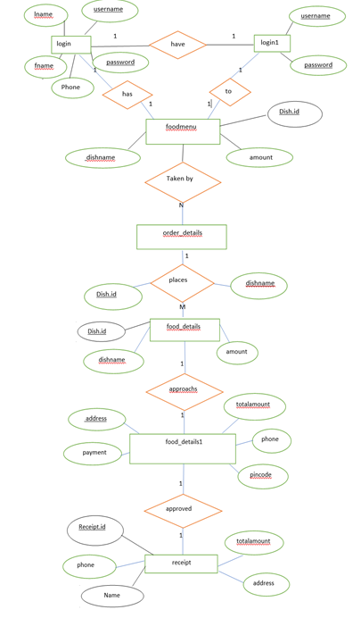
Fig 3.1 ER DIAGRAM of Swift and Sweet Food Management System

The figure shows the representation of ER diagram of Swift and Sweet Food Management System. It contains the connection i.e relation between the entities and the participation ratio. And the primary key is underlined as we see in figure and foreign keys are the keys that relate to primary key of other table represented by connecting to that table.
Chapter-4
SCHEMA DIAGRAM
Login
Fname Lname username password phone

Login1
Username password

foodmenu
Dish.id Dishname amount

Orderdetails
Dish.id Dishname

food_details1
address pincode total amount payment phone

receipt
Receipt.id Name address total amount phone

Fig 4.1 SCHEMA DIAGRAM of Swift and Sweet Food Management System
The fig. shows the representation of Schema dig. of Swift and Sweet Food Management System. It contains all the tables used in this mini project and these tables are connected to each other with respect to primary keys and foreign keys. Here primary keys are represented by underlining it and foreign keys are connected to the table of that particular primary key is present.

Chapter-5
DATA TABLES
Login table:
Sl.No. | Field Name | Data type | Description
1 | Fname | VARACHAR(20) | Stores the Fname .
2 | Lname | VARCHAR(20) | Stores the Lname.
3 | username | VARCHAR(20) | Stores the username.
4 | password | VARCHAR(20) | Stores the password.
5 | phone | number | Stores the phone number

Login1 table :
Sl.No. | Field Name | Data type | Description
1 | username | VARACHAR(20) | Stores the username.
2 | password | VARCHAR(20) | Stores the password.

foodmenu table :
Sl.No. | Field Name | Data type | Description
1 | Dish.id | Varchar(20) | Stores the dishid
2 | dishname | VARACHAR(20) | Stores the dishname
3 | amount | Number | Stores the amount.

orderdetails table :
Sl.No. | Field Name | Data type | Description
1 | dishid | Varchar(20) | Stores the dishid
2 | dishname | VARACHAR(20) | Stores the dishname
3 | amount | Number | Stores the amount.

Food _details1 table :
Sl.No. | Field Name | Data type | Description
1 | address | VARACHAR(20) | Stores the address
2 | pincode | number | Stores the pincode.
3 | totalamount | number | Stores the totalamount
4 | payment | VARCHAR(20) | Stores the payment
5 | phone | number | Stores the phone number

Receipt table :
Sl.No. | Field Name | Data type | Description
1 | Name | VARCHAR(20) | Stores the name
2 | Phone | Number | Stores the phone number
3 | Address | VARCHAR(20) | Stores the address
4 | Totalamount | Number | Stores the totalamount

Chapter-6
SOURCE CODES

6.1 INSERT STATEMENTS:
public connection conn=new connection();
public Connection conx=null;
PreparedStatement pst;
ResultSet rs;

txt1.setText(p1);
txt2.setText(p2)
try{
conx=conn.getConnection();
String sql="insert into food_details(dishname,amount)values(?,?)";
pst=conx.prepareStatement(sql);
pst.setString(1, txt1.getText());
pst.setString(2, txt2.getText());
rs=pst.executeQuery();
if(rs.next()){
fooddetails o=new fooddetails();
o.setVisible(true);
setVisible(false);
}}
catch(SQLException e){
e.printStackTrace();
}
6.2 DELETE STATEMENT:
public connection conn=new connection();
public Connection conx=null;
PreparedStatement pst;
ResultSet rs;{
String sql="DELETE FROM food_details WHERE DISHNAME=?";
try{
conx=conn.getConnection();
pst=conx.prepareStatement(sql);
pst.setString(1, jTextField1.getText());
pst.execute();
JOptionPane.showMessageDialog(null, "deleted");
} catch (SQLException ex) {
Logger.getLogger(fooddetails.class.getName()).log(Level.SEVERE, null, ex);
}
update();
}
{
try{
conx=conn.getConnection();
int row=txttable1.getSelectedRow();
String r=(txttable1.getModel().getValueAt(row, 0).toString());
String sql="select * from food_details where dishname='"+r+"'";
pst=conx.prepareStatement(sql);
rs=pst.executeQuery();
if(rs.next()){
String h=rs.getString("dishname");
jTextField1.setText(h); }
} catch (SQLException ex) {
Logger.getLogger(foodmenu.class.getName()).log(Level.SEVERE, null, ex);
}
}
6.3 UPDATE STATEMENTS:
public connection conn=new connection();
public Connection conx=null;
PreparedStatement pst;
ResultSet rs;
private Object jtxtTable1;
private Object txt_DISHNAME;
public fooddetails() {
initComponents();
update();
foodmenu y=new foodmenu();
y.setVisible(true);
setVisible(false);
private void update(){
try{
conx=conn.getConnection();
String sql="select p.dishname,p.amount from food_details p";
pst=conx.prepareStatement(sql);
rs=pst.executeQuery();
txttable1.setModel(DbUtils.resultSetToTableModel(rs));
}
catch(SQLException e){
e.printStackTrace();
}

6.4 VIEW STATEMENTS
public connection conn=new connection();
public Connection conx=null;
PreparedStatement pst;
ResultSet rs;
try{
conx=conn.getConnection();
String sql="select p.dishname,p.amount from food_details p";
pst=conx.prepareStatement(sql);
rs=pst.executeQuery();
txttable1.setModel(DbUtils.resultSetToTableModel(rs));
}
catch(SQLException e){
e.printStackTrace();
}
try{
conx=conn.getConnection();
int row=txttable1.getSelectedRow();
String r=(txttable1.getModel().getValueAt(row, 0).toString());
String sql="select * from food_details where dishname='"+r+"'";
pst=conx.prepareStatement(sql);
rs=pst.executeQuery();
if(rs.next()){
String h=rs.getString("dishname");
jTextField1.setText(h); }
} catch (SQLException ex) {
Logger.getLogger(foodmenu.class.getName()).log(Level.SEVERE, null, ex);
}
}

Chapter-7
SNAPSHOTS

7.1 Admin Login Page:

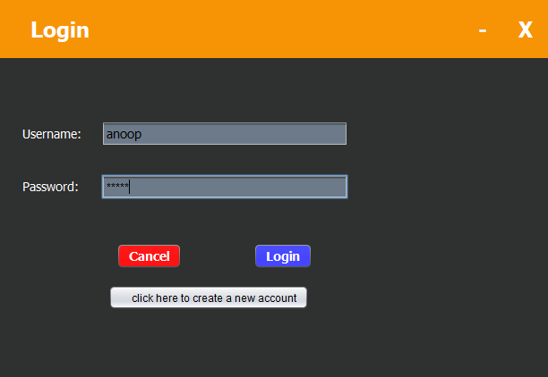
Fig 7.1 Admin page login

Admin need to enter user name and password and press login if username and password correct then admin will be switched on to next page if incorrect password then he is not able to open the next page. Before being login of he didn’t registered his details he supposed to submit his details in next page if registred he can be able to proceed to next page.

7.2 Register page :-
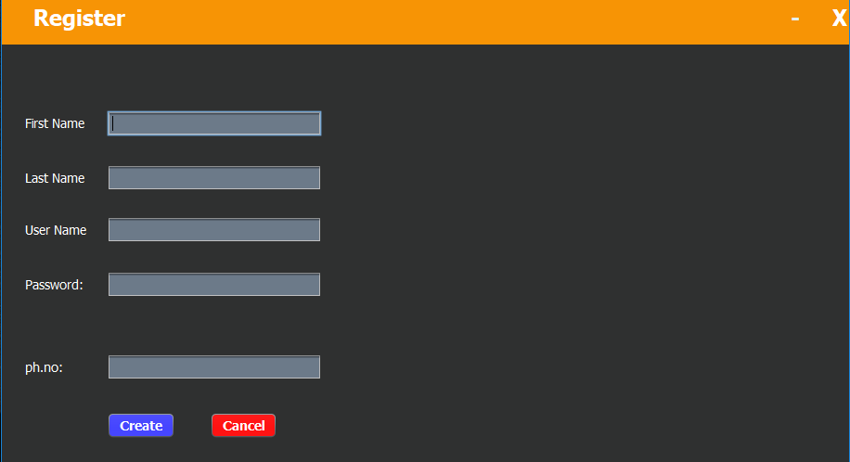
Fig 7.2 Register page
Here in this page user can submit his fname, lname, username, password other details and also the phone number have to be given in order to successfully login and then he can be able to connect to the next page.

3) Foodmenu page:-
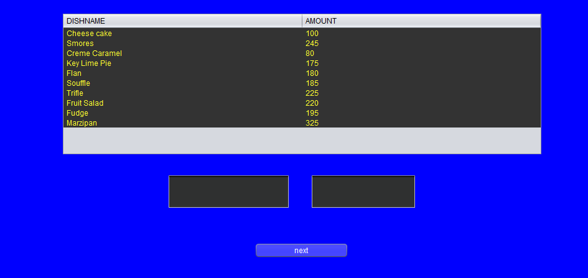
Fig 7.3 Foodmenu page
This page stores the information about the food menu that are being used by the admin to manage his requirements. In this page the Admin can perform insertion operation on thefoodmenu. The operation that can be performed is insert,. The admin can even remove the select dishname in the upcoming page.

7.4 Orderdetails page:-

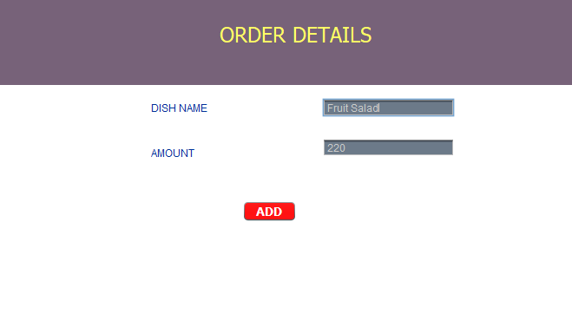

Fig 7.4 Order details

This page stores the information about selected dishname. The operation that can be performed by the Admin are insert, delete, update and also can be viewed in upcoming page.

7.5 Food_details page :-

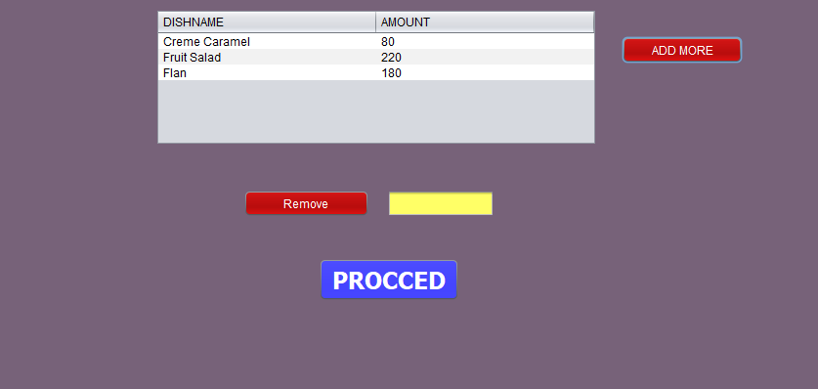
Fig 7.5 Food_details page
This page stores all the details of the food required for the user, here the user can perform the operations such as insertions, deleation i.e he can remove the selected dishname and also the table can be viewed as updated here and by this we can display the dishnames and further we can prefer to the proceed option such that we can move to the next page.

7.6 Food_details1 Page :-
Here the admin can give the address where the food has to be reached and then by he has to enter the pincode followed by just clicking the get button the total amount which has to be paid will be calculated and also he can prefer his method of paying followed by the phone number and by clicking the update command user can move to next page .

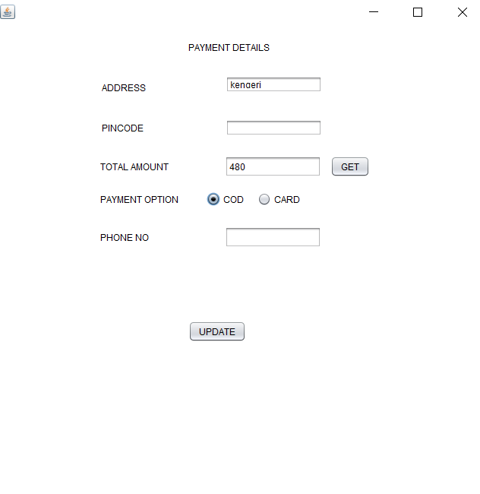

Fig 7.6 Food_details1 Page
7.7 Receipt Table:
Followed by update button here the final dishname can be viewed i.e the dishnames which are ordered can be displayed here in this table, the total amount , address and the phone number are some of the basic info. about the user.

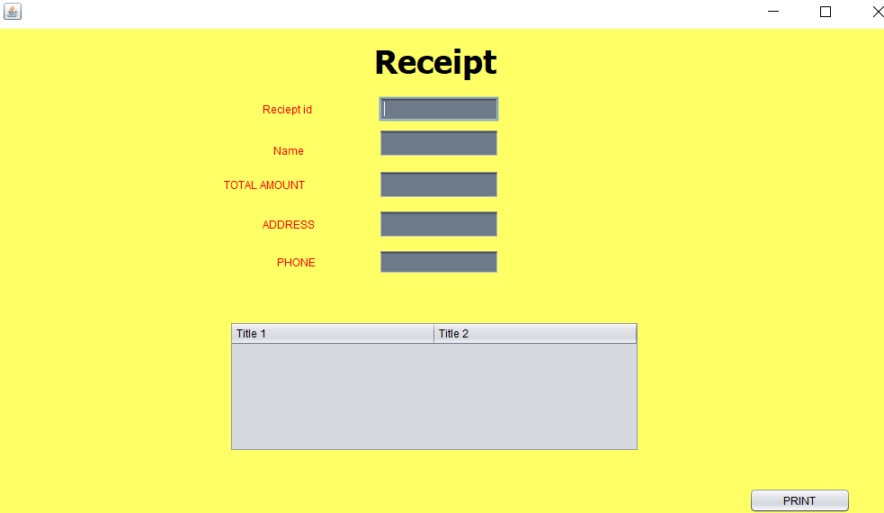

Fig 7.7 Receipt Table

7.3.1 Insertion Operation:
In this if the value is inserted then an appropriate dialog box is displayed informing the success of the insertion operation. If the value is not correctly entered with respect to unique constraint , then an error message dialog box will be displayed informing the admin about the error that has been occurred.

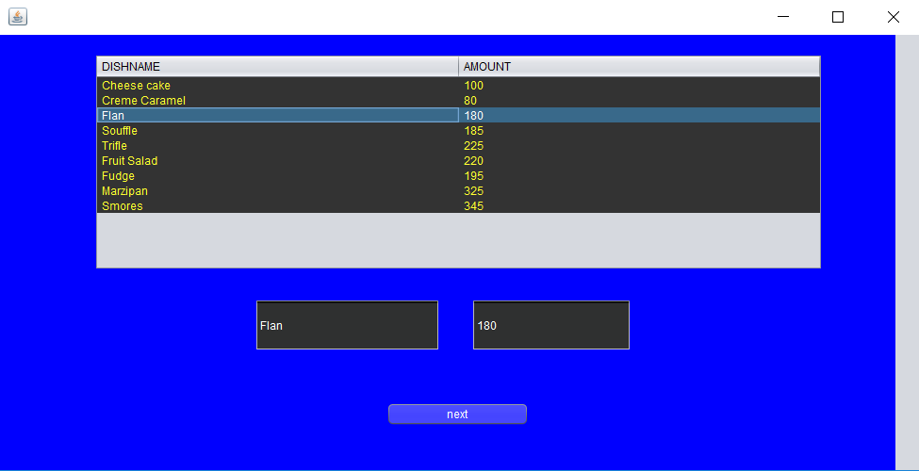
Fig 7.3.1 Insertion operation sample
7.5.1 Deletion Operation:
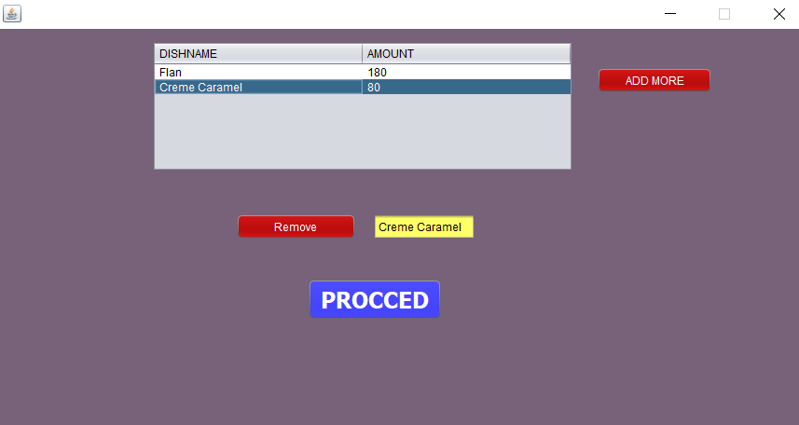
Figure 7.5.1 Deletion operation sample
In this if the value is deleted then an appropriate dialog box is displayed informing the success of the deletion operation. If the value is not entered correctly, then an error message dialog box will be displayed informing the admin about the error that has been occurred.

7.4.1 Update Operation:
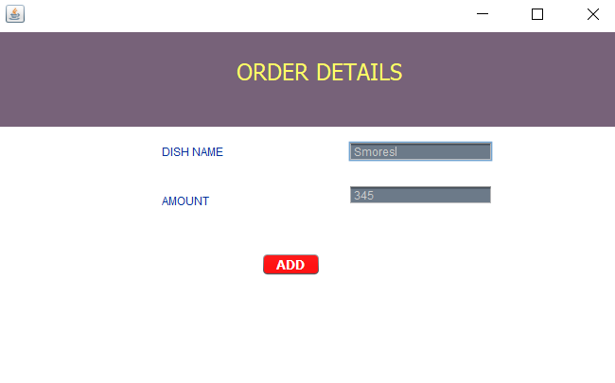
Figure 7.4.1 Update operation sample
In this if the value is updated then an appropriate dialog box is displayed informing the success of the update operation. If the unique value or attribute is changed, then an error message dialog box will be displayed informing the admin about the error that has been occurred.

7.5.3 Display Operation:
In this if all the values are inserted, if we press display, then all the values are displayed in the table. If the value is not entered correctly, then an error message dialog box will be displayed informing the admin about the error that has been occur

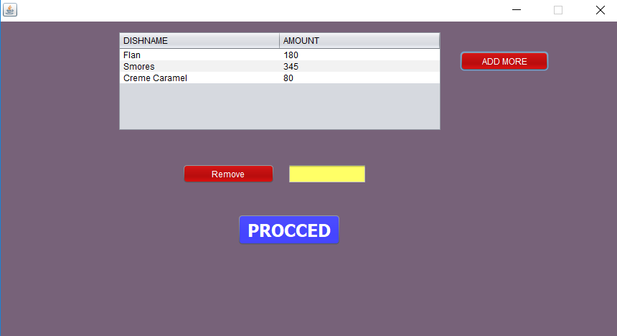
Figure 7.5.3 Display operation sample

Chapter 8
CONCLUSION
The Project “Swift and Sweet Food Management System” is designed in order reduce the burden of maintaining bulk of records of all the property details in which Inserting , Retrieving and updating the Details are easy when it is compared to the manual update and storing. This project helps in ordering the food and also to maintain the database details and to replace old paper work system.

REFERENCES
1. Reference Book :- Java The Complete Reference.
2. Website:-
*. https://docs.oracle.com/javase/7/docs/api/javax/swing/package-summary.html
*. https://netbeans.org/kb/docs/java/quickstart-gui.html
*. https://www.w3schools.com/sql
*. https://stackoverflow.com/

